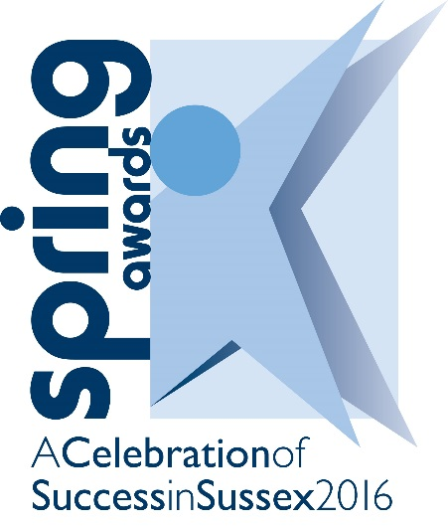

www.fesussexspringawards.org
19/11/15
Sussex ‘A’ Level/IB Learner of the Year
Sponsored by
Guidelines
Who should enter?
This award is open to students studying for or who have already completed their A level or IB studies. It will be made to the A level/IB student who:

- Has shown outstanding academic ability throughout their A level or IB studies together with a high level of commitment to supporting the college through extra curricula activities.

What is the judging process?
The award will be made to the student judged to be the learner who has shown the highest level of academic achievement on their A level or IB course and who have also made a large contribution to college life. It is open to students studying at any stage of their A level or IB studies. To win this award you must tell the judges how you have shown

- The highest level of academic achievement
- The development of personal qualities through making a large and notable contribution to college life through extra curricula activities

Entrants and tutors are recommended to take full notice of the weighting of scores attached to each request for information. The judges will mark your entry from the information you and your tutor provide so it is important for you to include all relevant examples and supporting statements. The use of supporting digital images is limited to two per entry and should not be considered as a replacement to text but a supplement. The decision of the judges is final.

You are welcome to submit an entry for more than one category, however you may only win one award. Should you be successful either as a Winner or Runner-up in more than one category individual scores will be taking into account in order to allocate the appropriate award to you.

How do you enter?
You can download an electronic entry form from www.fesussexspringawards.org. It can be completed electronically or by pen.

All sections on the form must be completed. Incorporate photos and other supporting evidence into the text boxes.

Entries need to be emailed to anna@fesussex.org.uk.

Important Dates- AMENDED
Closing date for submission of entries | 12noon, Monday 29th February 2016
Evening of celebration by invitation only | Wednesday 4th May 2016

Ceremony and Publicity
By entering for an award you are agreeing to the publicity that surrounds the ceremony. Winners and runners up will be invited to a ceremony at the Hilton Brighton Metropole Hotel on Wednesday 4th May 2016 (4pm – 9pm).

All winners will be filmed at their college or workplace before the ceremony for a short film clip that will be shown on the night. Runners up will need to be photographed before the night. An official photographer and film crew will be taking photos and filming throughout the award ceremony. The film and photographs will be used for publicity purposes. Photos will be available for purchase after the event.

Entry Form 2016
SECTION ONE - Background Information

Personal details

Name
Address

Contact telephone number
Email address
Age

Course details

Name of college
Name of course
Start date of course
End date of course
Any other course details

All entries must be emailed to anna@fesussex.org.uk

PLEASE NOTE: By submitting an entry to the Spring Awards, permission is hereby given for the information in the entry to be used by the Spring Awards for any publicity as deemed appropriate. If you have revealed sensitive information that you do not wish to be publicised then please advise us.

SECTION TWO
Using the following boxes, please tell the judges how you have shown

The highest level of academic achievement in your A level or IB studies
(25 marks eg: Tell us your grades (which must be outstanding) for your A level or IB studies. The number of subjects you take will also contribute towards the marks awarded).

Contribution to college life through extra curricula activities
(20 marks. Tell us what societies and college activities you have played a major part in. How will the work you have done continue when you have left your college? What makes your contribution so much better than your fellow students? How will you use the experience you have gained to help you as you start your higher education or enter employment?)

Development of personal qualities
(5 marks. Tell us how you have developed new levels of self-confidence which have enabled you to undertake activities or tackle situations that you would have previously found extremely difficult? What do you do to help others when you are outside work or college?)

SECTION THREE - Endorsement
This section is for a member of teaching staff to complete.
Please describe why you believe this learner deserves to be considered for a Spring Award.

Endorser’s name
Position
College
Email
Telephone number
Date

All entries must be emailed to anna@fesussex.org.uk

PLEASE NOTE: By submitting an entry to the Spring Awards, permission is hereby given for the information in the entry to be used by the Spring Awards for any publicity as deemed appropriate. If you have revealed sensitive information that you do not wish to be publicised then please advise us.

