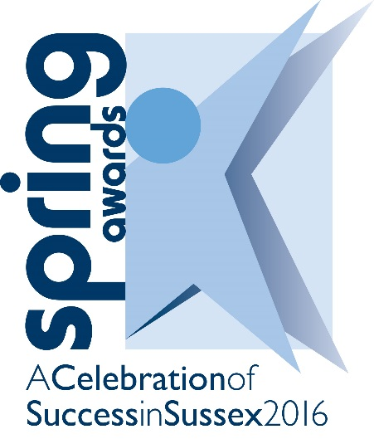

www.fesussexspringawards.org
19/11/15
NCFE Sussex Learner of the Year
Sponsored by
Guidelines
Who should enter?
This award is open to students in Sussex studying full-time or part-time for NCFE qualifications in any subject.

What is the judging process?
The award will be made to the student judged to be the learner who has consistently applied themselves to their studies on a NCFE course. It is open to students studying at any level. To win this award you must tell the judges how you have shown

- Diligence in studies and genuine interest in the course
- Consistent application to learning and acquisition of vocational skills
- Overcoming challenges, barriers and obstacles to learning
- Progress made from starting the course taking into account previous education experience & level
- Development of personal qualities

Entrants and tutors are recommended to take the full notice of the weighting of scores attached to each request for information. The judges will mark your entry from the information you and your tutor provide so it is important for you to include all relevant examples and supporting statements. The use of supporting digital images is limited to two per entry and should not be considered as a replacement to text but a supplement. The decision of the judges is final.

You are welcome to submit an entry for more than one category, however you may only win one award. Should you be successful either as a Winner or Runner-up in more than one category individual scores will be taking into account in order to allocate the appropriate award to you.

How do you enter?
You can download an electronic entry form from www.fesussexspringawards.org. It can be completed electronically or by pen.

All sections on the form must be completed. Incorporate photos and other supporting evidence into the text boxes.

Entries need to be emailed to anna@fesussex.org.uk.

Important Dates - AMENDED
Closing date for submission of entries | 12noon, Monday 29th February 2016
Evening of celebration by invitation only | Wednesday 4th May 2016

Ceremony and Publicity
By entering for an award you are agreeing to the publicity that surrounds the ceremony. Winners and runners up will be invited to a ceremony at the Hilton Brighton Metropole Hotel on Wednesday 4th May 2016 (4pm – 9pm)

All winners will be filmed at their college or workplace before the ceremony for a short film clip that will be shown on the night. Runners up will need to be photographed before the night. An official photographer and film crew will be taking photos and filming throughout the award ceremony. The film and photographs will be used for publicity purposes. Photos will be available for purchase after the event.

Entry Form 2016
SECTION ONE - Background Information

Personal details

Name
Address

Contact telephone number
Email address
Age

Course details

Name of college
Name of course
Start date of course
End date of course
Any other course details

All entries must be emailed to anna@fesussex.org.uk

PLEASE NOTE: By submitting an entry to the Spring Awards, permission is hereby given for the information in the entry to be used by the Spring Awards for any publicity as deemed appropriate. If you have revealed sensitive information that you do not wish to be publicised then please advise us.

SECTION TWO
Using the following boxes, please tell the judges how you have shown

Diligence in studies and genuine interest in your course
(15 marks. eg: How have you demonstrated your seriousness about the course? Why do you find it interesting? What makes you want to learn more? Why do you, your tutors and fellow learners think you are a good student?)

Consistent application to learning and acquisition of vocational skills
(15 marks. eg: Progress made since starting the course. What level of skills have you developed? What high grades have you achieved? How have you extended your knowledge beyond the requirements of the course? How have you/intend to apply what you have learnt on the course to extend your education, training and prospects?)

Challenges and barriers and how these have been overcome
(10 marks. Tell us what you have had to work hard at overcoming and, therefore, what makes you stand out from the crowd)

Progress made from starting the course taking into account previous education experiences
(5 marks. Tell us what you did before your course and how you have progressed as a result of the course. Give some examples for the judges. For example, you may have started your course with little or no knowledge of the subject area you are now becoming an expert in!).

Development of personal qualities
(5 marks eg How you have developed new levels of confidence which have enabled you to undertake activities or tackle situations that you would have previously found extremely difficult).

SECTION THREE - Endorsement
This section is for a member of teaching staff / training provider to complete.
Please describe why you believe this learner deserves to be considered for a Spring Award.

Endorser’s name
Position
College
Email
Telephone number
Date

All entries must be emailed to anna@fesussex.org.uk

PLEASE NOTE: By submitting an entry to the Spring Awards, permission is hereby given for the information in the entry to be used by the Spring Awards for any publicity as deemed appropriate. If you have revealed sensitive information that you do not wish to be publicised then please advise us.

